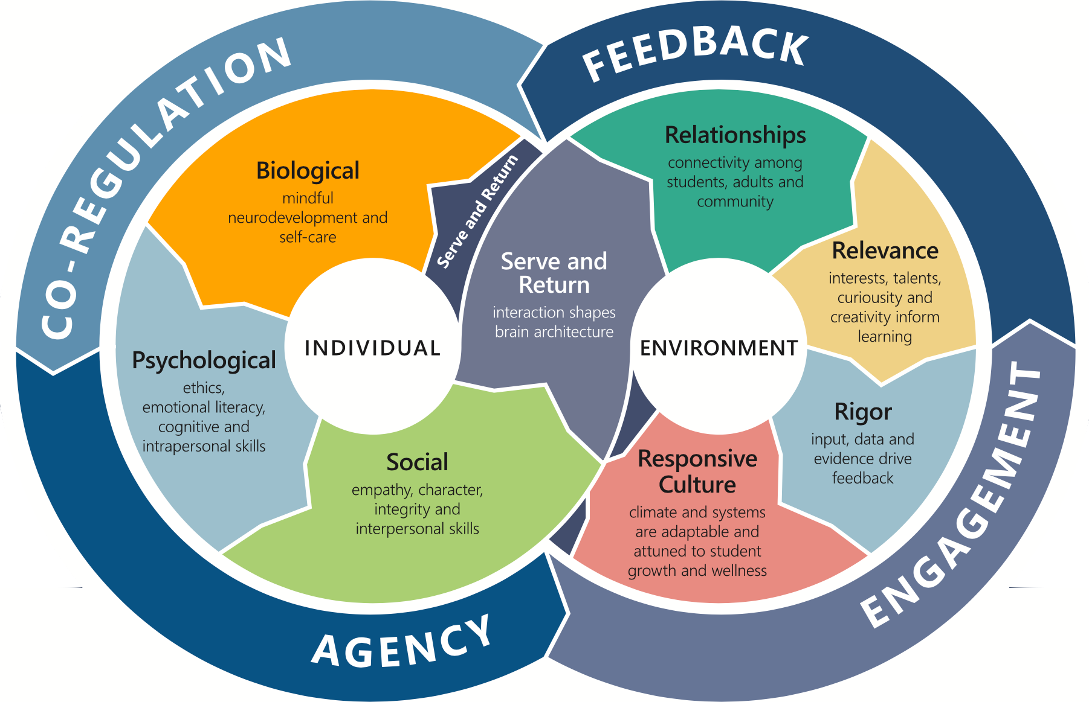

Kansans CAN Integrated Learning Process
Trisha Backman
2026-04-29 18:58:44
--------------------------------------------
@kelly.steele@ksde.gov Here is the Integrated Learning Process document
To lead the world in the success of each student, Kansas educators increasingly recognize the need to more fully integrate the science and principles of human development into proven educational practices. The Kansas State Department of Education developed a practical tool to illustrate a visionary and dynamic process for developing the whole child called the Kansans Can Integrated Learning Process.

Explaining the Process for Integrating Social-Emotional and Academic Development: Individuals, from child to adult, have biological, psychological and social dimensions that are developed in a holistic education. In the Kansas accrediting model, the environment supports this through a focus on relationships, relevance, rigor, and responsive culture. A growth-promoting process, represented here in a continuous feedback loop, creates the integrative experience that propels learning and well-being.
The five growth principles of the Integrated Learning Process start with the central concept of serve and return. At the heart of the process, it is the fundamental interaction that shapes brain architecture. When a child expresses a need (serve) and receives a constructive response from an adult (return), neural connections are built that support the development of learning, social skills, communication and a healthy nervous system.
This positive serve and return interaction is the basis for co-regulation, in which the regulated nervous system of the adult signals and implicitly assists the regulation of the student’s nervous system. This creates the safety and attachment necessary for developing more explicit skills needed to regulate personal behavior and develop mutually satisfying relationships. Learning to self-regulate is foundational to developing agency. Agency includes the growing ability to make decisions about one’s own life and influence one’s environment. As a student develops a sense of control and influence, confidence and motivation to fully engage in the learning environment increase. Engagement is critical for both academic and social-emotional learning.
Classrooms rich in connectivity, collaboration, and supportive relationships; that provide students the opportunity to practice relevant choice and decision-making regarding interests; that foster observation and self-reflection; are classrooms that integrate and promote social emotional and academic growth. The results of these interactions provide the student and teacher with feedback, which offers more opportunities for serve-and-return interaction, co-regulation, and the infinite learning process continues…

