Bullying Prevention Toolkit


A TOOLKIT FOR KANSAS SCHOOLS

Kansas leads the world in the success of each student.
October 13, 2025

Contents
INTRODUCTION 5
KANSAS STATE STATUTE 6
Bullying Prevention 12 Step Plan Infographic 7
PREVENTION 9
Define Bullying Behaviors 11
Establish the School Mental Health Team 15
Training Options and Requirements 16
INTERVENTION 19
Identify How to Report Bullying 21
School Mental Health Team Investigation 23
What if the behaviors investigated are suspected to be a crime? 25
Notify Family 26
POSTVENTION 27
Skill Training 29
Progress Monitoring 30
Appealing a Decision 31
RESOURCES 35
Special Attention Note: The Intersection of Bullying and Suicide 37
School Mental Health Bullying Prevention Workgroup Members 40
APPENDIX 41
  - Bullying Definition Infographic 43
  - SMHT Identification Tool 44
  - Bullying Involvement Investigation Process Checklist 45
  - Bullying Report Template 48
  - Bullying Interview 51
  - Teacher Interview of Bullying Incident Template 53
  - Evaluating Existing Records Template 55
  - SMHT Investigation Template 58
  - Sample letter to Caregiver Outcome of Bullying Investigation 60
  - Student Skill Building Report 61
  - SMHT Progress Monitoring Template 64

CONTENTS

Introduction
Bullying in schools has been a persistent problem for generations. In April 2019, Kansas Commissioner of Education Randy Watson appointed a blue-ribbon task force to examine issues of bullying in the state’s schools and report recommendations to the Kansas State Board of Education (KSBE) by December 2019. The task force’s final report was intended to “help school boards, administrators, teachers, students, families and communities in addressing this persistent problem,” and offered the following recommendations:
- Provide better support and direction for school districts.
- Continue to develop the state’s focus on social-emotional and character development education to address school bullying.
- Examine the current state bullying law and determine if it requires reconsideration.
- Local policies and plans must focus on relationships, school climate and culture and the mental health impact of bullying in schools.
- The state needs better data on school bullying and measures for assessing program effectiveness.
- Address cyberbullying.
- Provide training, professional development, and teacher preparation regarding bullying.
The State Board accepted these recommendations and tasked the School Mental Health Advisory Council (SMHAC) with developing guidance for implementation. The SMHAC advises the State Board on issues related to school mental health.

In 2021, the SMHAC drafted implementation guidelines for bullying prevention. In 2025, the SMHAC then requested a bullying prevention workgroup with the purpose of creating templates and guidance to complement the implementation guide checklists created in 2021. The templates in this toolkit are intended for schools, school mental health teams (SMHT) and local boards of education to develop and implement local policies, procedures, and practices for system compliance with K.S.A. 72-6147(c). The following information and templates are a framework for districts to use while building their local policies, procedures, and practices for preventing, intervening, and supporting individuals involved in bullying. This framework has been adapted from the work of Dr. Chad Rose, Missouri Bullying Prevention Lab. Dr. Rose and his team have researched and studied evidence-based practices to deter and eliminate bullying in schools since 2009. The edits have been approved by Dr. Rose to best fit the needs of Kansas schools and communities. We thank Dr. Rose and his team for sharing this work with us and their tireless work in the field of bullying prevention.

When effective bullying prevention is implemented as part of a systemic, prevention-focused, responsive approach to bullying behaviors, schools enhance the conditions necessary for learning. Bullying prevention, intervention, and postvention also build a safer school climate and culture. When both factors are in place, districts build settings for rigorous student achievement and thriving Kansas communities.

BULLYING PREVENTION TOOLKIT

Kansas State Statute
72-6147. Bullying, school district policies.
- As used in this section:
  - “Bullying” means:
    - Any intentional gesture or any intentional written, verbal, electronic or physical act or threat either by any student, staff member or parent towards a student or by any student, staff member or parent towards a staff member that is sufficiently severe, persistent or pervasive that such gesture, act or threat creates an intimidating,
threatening or abusive educational environment that a reasonable person, under the
circumstances, knows or should know will have the effect of:
      - Harming a student or staff member, whether physically or mentally;
      - damaging a student’s or staff member’s property;
      - placing a student or staff member in reasonable fear of harm to the student or staff member; or
      - placing a student or staff member in reasonable fear of damage to the student’s or staff member’s property;
    - cyberbullying; or
    - any other form of intimidation or harassment prohibited by the board of education of the school district in policies concerning bullying adopted pursuant to this section or subsection (e) of K.S.A. 72-1138, and amendments thereto.
  - “Cyberbullying” means bullying by use of any electronic communication device through means including, but not limited to, e-mail, instant messaging, text messages, blogs, mobile phones, pagers, online games and websites.
  - “Parent” includes a guardian, custodian or other person with authority to act on behalf of
the child.
  - “School district” or “district” means any unified school district organized and operating under
the laws of this state.
  - “School vehicle” means any school bus, school van, other school vehicle and private vehicle used to transport students or staff members to and from school or any school-sponsored activity or event.
  - “Staff member” means any person employed by a school district.
- The board of education of each school district shall adopt a policy to prohibit bullying either by any student, staff member or parent towards a student or by a student, staff member or parent towards a staff member on or while utilizing school property, in a school vehicle or at a school-sponsored activity or event.

BULLYING PREVENTION TOOLKIT
KANSAS STATE STATUTE

- The board of education of each school district shall adopt and implement a plan to address bullying either by any student, staff member or parent towards a student or by a student, staff member or parent towards a staff member on school property, in a school vehicle or at a school-sponsored activity or event. Such plan shall include provisions for the training and education for staff members and students.
- The board of education of each school district may adopt additional policies relating to bullying pursuant to subsection (e) of K.S.A. 72-1138, and amendments thereto.
- Nothing in this section shall be construed to limit or supersede or in any manner affect or diminish the requirements of compliance by a staff member with the provisions of K.S.A. 38-2223 or 38-2226, and amendments thereto.

History: L. 2007, ch. 185, § 4; L. 2008, ch. 77, § 1; L. 2013, ch. 121, § 15; July 1.

Bullying Prevention 12 Step Plan Infographic
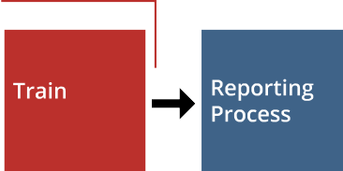


This page blank for printing purposes.

BULLYING PREVENTION TOOLKIT
Prevention

Bullying Prevention 12 Step Plan

INTERVENTION
PREVENTION
Establish SMHT
Notify Parent
Identify
Skill Deﬁcit
Local Formal Appeal Process
POSTVENTION

Deﬁne
Behaviors

Train

Monitor Progress

Interview

Team Review

Decision

Investigate

Reporting Process

PREVENTION

This page blank for printing purposes.

Define Bullying Behaviors
PREVENTION

Giving students and families clear terms will improve incident reporting, and these terms should be included in their training and available on the school website where behaviors are explained.
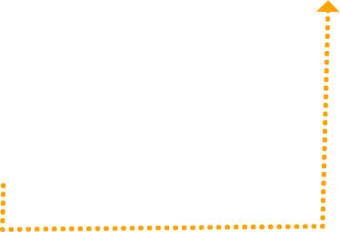

Bullying Deﬁnition
NO
YES
NO
YES
BULLYING
NO
YES
NOT
B G
ULLYIN
Results in reasonable fear of damage to property
YES NO
YES NO
YES NO
YES NO

Results in actual damage to property
Results in reasonable fear of physical or mental harm

Results in actual physical or mental harm
Creates an intimidating, threatening or
abusive educational environment
Severe, persistent or pervasive
Intentional Act
(gesture; written, verbal or electronic communication; physical act; or threat)

There are five types of bullying: physical, cyber, verbal, property damage, and relational.
- Physical Bullying
- Cyberbullying
- Verbal Bullying
- Relational Bullying
- Property damage

- Physical bullying involves the use of physical force to target an individual or group of students.
Physical bullying involves hurting a person’s body or possessions and occurs when a person uses overt bodily acts to gain power over peers. Physical bullying also includes:

  - Hitting/kicking/pinching
  - Spitting
  - Tripping/pushing/shoving
  - Taking or breaking someone’s personal property
  - Making mean or rude hand gestures
  - Hazing
  - Serious bodily injury (under physical bullying): A bodily injury that involves a substantial risk of death; extreme physical pain; protracted and obvious disfigurement; or protracted loss or impairment of the function of a bodily member, organ or faculty. (18 USC Section 1365(h)(3)) this should be reported to law enforcement.

- Cyberbullying involves behaviors with the intent of harming an individual through electronic means:

  - Social media
  - Text messages
  - Gaming
  - Mobile applications
  - Rumor spreading on a device
  - Posting, reposting, or possessing compromising pictures (may also be considered possession of porn and require reports to local law enforcement)
  - Name calling
  - Encouragement of social exclusion
  - Encouragement of self-harm or suicidal behaviors

- Verbal bullying may involve oral or written communication.
Verbal bullying occurs when someone uses language to gain power over a person. This power causes harm or intends to cause harm to the target including:

  - Teasing
  - Taunting
  - Name-calling
  - Threats
  - Offensive language or notes/emails/
texts/chats
  - Derogatory hand gestures
  - Inappropriate sexual comments
  - Severe criticism
  - Belittling
  - Personal defamation
  - Racist slurs
  - Sexually suggestive and/or abusive remarks
  - Extortion
  - Sextortion

PreventIon | DefIne BullyIng BeHavIorS

- Relational bullying involves behaviors designed to socially exclude or damage the reputation of the target or the systemic diminishing of a target’s sense of self that could lead to rejection or alienation.
These behaviors may include:
  - Rumor spreading
  - Social isolation
  - Ignoring
  - Encouraging others to unfriend the target
  - Isolating
  - Excluding
  - Shunning
  - Gossiping

- Damage to property
Damage to property involves an aggressor intentionally damaging or stealing an individual’s property with the intent of causing harm or destruction.

WHEN A TEACHER IS BEING BULLIED BY ANOTHER TEACHER OR PARENT

Kansas laws state bullying can occur in any location, by any person. This means the potential bullying could be done by any student, teacher, or family member. It also means bullying can target any student, teacher, or family member. All employers are required to protect their staff from harassment. Just as bullied students are at a high risk of anxiety, depression, and other health problems, so are bullied adults.
- Report the behavior(s) to the building administration in writing. Copy this notification to assistant principals and the superintendent as well. These administrators may choose to take this information to the local board of education to provide further protection to the teacher from the parent.
- A request for remediation may be appropriate if a restorative practice option is reasonable. This may not be a reasonable solution if the person targeted is uncomfortable with this option. Discuss options the targeted adult would consider and negotiate next steps. A written contract with the bully and the school may be a good next step and could include the following:
  - The building administrator directs all further communication through them and insists the bully immediately cease to contact the adult being targeted.
  - All communication is to be written/in email and delivered through the principal. Communications need to cease being verbal or online. Any failure to follow this request could be considered harassment. The targeted adult has the right to file a legal complaint against the bully with local law enforcement.
- Please explore adjusting the schedule to minimize adult interactions, possibly by assigning the shared student to a different teacher from the one being affected.
- Consider recommendations for social skill building for the bullying adult such as anger management,
conflict resolution, or mental health services.
- Do not allow the bullying adult on campus without an appointment and building staff present.
- If the bullying continues, or if the teacher feels the school is not addressing the report of bullying from a parent, call local law enforcement to report the harassment.
- The U.S. Department of Justice, Civil Rights Division1, could also be contacted to file a complaint.

1 Contact the Civil Rights Division | Department of Justice. (n.d.). https://www.justice.gov/crt/contact-us-0

Establish the School Mental Health Team
PREVENTION

Bullying should be addressed with a team approach as it is with other supportive school culture work such as suicide prevention, student threat screening, and mandated reporting. This comprehensive approach supports the whole child and strengths-based best practices. Using a whole-child, collective view of each student and situation will help the School Mental Health Team (SMHT) evaluate the behavior(s), gather data, and identify the potential root cause of a student‘s behavior. This team approach should be implemented for the bully and the target.

School psychologists, school social workers, school counselors and school nurses are trained in assisting students, those who are bullying and their targets, and their families. In accordance with the Jason Flatt Act suicide prevention regulations requirements, each Kansas school district must have an district- and building-level mental health team. Direct contact information for these teams’ members should be posted on the district and schools’ websites for transparency for parents, guardians and caregivers for when a concern arises. These teams could serve as the district’s bullying prevention taskforce. (Members of the school mental health team should also refer to 1-02 SMHT Identification Tool.)

(The Kansas State Department of Education recognizes not all districts have robust school mental health teams.
Each district will exercise local control in developing its policies, procedures, and practices, and should play to the strengths of their team members as well as the needs of their staff, students, and community when determining the capacity of their mental health leads.)

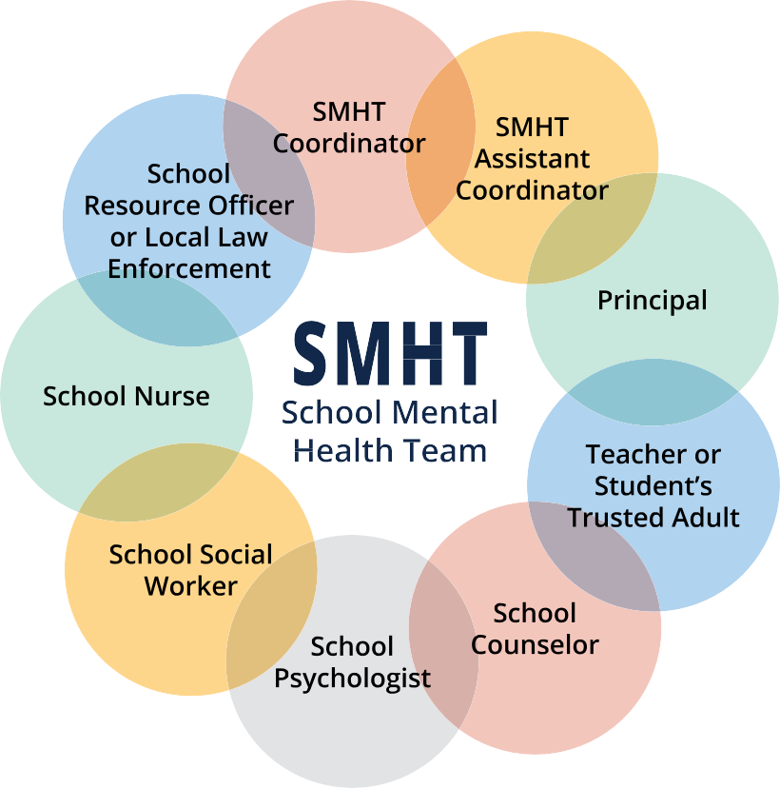
responsibilities of the SMHt for reported bullying incidents
- Establish a bullying prevention action plan with clear timelines.
- Establish bullying prevention protocols.
- Establish reporting protocols.
- Review bullying reports.
- Conduct the investigation.
- Collect data.
- Conduct interviews.
- Meet as a team to determine root cause of the behaviors and recommended skill trainings.
- Communicate with parents.
- Implement intervention.
- The SMHT may follow the
  - Bullying Involvement Investigation Process Checklist.

PREVENTION

Training Options and Requirements
- The SMHT will investigate the current trainings being used and measure if they meet the needs of adopted, local board of education policies, procedures, and practices.
- The SMHT will bring recommendations for training to their district leaders for annual student, staff, and
parent training.
- Building-level team members should have common language and training in their local board of education-approved policies so consistency in understanding what constitutes bullying and what type of implementation should be in place is demonstrated from building to building across the district.
- District- and building-level SMHT members should train all employees of the district on the local policies, procedures, and practices adopted by their local school board.
- Family training should be made available at age-appropriate levels for the students in their homes. This should include multiple methods of training and options for training to be accessed when parents are available (i.e., public training sessions, informational podcasts, district-created videos posted to the district’s and school’s websites, and pamphlets). Parents should become aware of the definition of bullying, the types of bullying, and effects they may see due to bullying. Parents should also be informed of the process to report bullying and what can be expected after they make a report. Finally, families should be informed of what decision was made by the SMHT when the reported incident was investigated and how to appeal a decision made by the SMHT in the event there is a disagreement with the team’s findings.

Schoolwide Culture Training: Build the Upstander Culture!

The Sandy Hook Promise organization has several events throughout the year to help students engage and minimize social isolation. Start With Hello (grades K-12) and Say Something (grades K-12) are activities that can be implemented district-wide as prevention or intervention strategies to combat bullying. Information about the Say Something anonymous reporting system and SAVE Promise Club, a youth-led organization, are both available at https://www.sandyhookpromise.org/our-programs/program-overview/

Upstander vs. Bystander
“If you see something, say something” means to take action when witnessing a concerning behavior or situation. Dr. Chad Rose of the University of Missouri Bullying Prevention Lab shares skill- and evidence-based bullying prevention and intervention methods that have been shown effective behavior modification results. https://www.mizzoubullypreventionlab.com/

Evidenced-based practices such as the Kansans Can Competencies can be trained schoolwide as a proactive and preventative practice for all students in all grades. Building a culture of protective factors against bullying means developing the expectation of students, staff, and parent(s)/guardian/caregivers to be upstanders and not bystanders. Upstanders make a choice to meaningfully engage when they see harmful or concerning behaviors or situations in an attempt to turn the situation in a positive direction. Districts should encourage students to move away from a situation and find a trusted adult if they do not feel empowered to act as an upstander.

PreventIon | traInIng oPtIonS anD reQuIreMentS

Using models such as the “5 Ds” presented by Stand UP against street harassment2 to address a problematic
behavior can effectively and supportively disengage the person who is acting out as a bully. The 5s are as follows:
- Direct: Say something to the person demonstrating concerning behaviors
- Delegate: Ask another person who is in the area to remove the target of the negative behavior
- Distract: The best distraction is to tell those not involved to keep moving and not engage in the situation. Allow the target to move away with the crowd. Other options of distraction may be choosing an off topic subject to discuss or engage in, walk with the person demonstrating the concerning behavior in the opposite direction, or do something off topic to move the attention away from where the concerning behavior is heading.
- Delay: Support the target and then talk to the person who demonstrated the concerning behavior later or after the person has walked away or is safe
- Document: Write down what happened and encourage others to build a culture of journaling what they see. If a person is unsure if the behavior is concerning, journaling can help identify patterns such as potential settings that activate the negativity, times of day, or other peer influences, etc. that could help focus the conversation with data and specifics.

listening is a critical skill in bullying prevention. Listening to “care and not to share” involves asking questions to clarify information to be sure if a behavior is of concern for safety. Communicating and demonstrating empathy can involve hearing and having difficult conversations. Making sure “I” statements are being used
and supportive language such as “bully” and “target” are identified can pinpoint facts of a situation. These specifics allow the SMHT to address the bullying incident when it is reported, follow the school’s protocols for investigating the incident, and determine a course of action needed to avoid repeated situations.
training students, staff, and families in standard responses helps each person know the appropriate course of action if they see suspected bullying. Training students in what to do, what to say, and who to tell builds protective factors for those who witness bullying as well as those who are bullied. When adults witness bullying, it is equally important for them to know a standard protocol. Training for staff and parents should include how to support the target of bullying, how to respond to bullying, and how to protect the reporter of retaliatory bullying.

2 Take the training - Stand Up. Take the Training - Stand Up. https://www.standup-international.com/us/en/training/landing

This page blank for printing purposes.

BULLYING PREVENTION TOOLKIT
Intervention

Bullying Prevention 12 Step Plan

INTERVENTION
PREVENTION
Deﬁne
Behaviors
Establish
SMHT
Train
Notify Parent
Identify Skill Deﬁcit
Local Formal Appeal Process
POSTVENTION

Monitor Progress

Interview

Team
Review

Decision

Investigate

Reporting
Process

INTERVENTION

This page blank for printing purposes.

Identify How to report Bullying
Each district must determine how they will receive reports of bullying. Equally as important is a clear protocol for who will monitor the reporting channels. Each method should be monitored at least daily. The reports should be allowed through multiple channels such as by phone, online reporting options, and other digital means available within the district. It also is critical for each report to be addressed, even those submitted anonymously.

Building a culture of felt safety means each report must be addressed the day it is received. StopBullying.gov1 advises students to attempt to tell their teacher, the school counselor, psychologist, or social worker, the school principal, or the superintendent. Teaching students each adult, regardless of their title, will hear a student’s concern helps reinforce the culture of felt-safety.
Determine the methods available for reporting and who will monitor reported incidents.
Verbal
Electronic
Types of Reports
Identiﬁed
Written Hard Copy
Anonymous


If a student sees another student being bullied, it is important for the student to know to whom to report it. It is important for students to be trained to identify how and when to step up and say something. Educating students and families about reporting suspicious activity also is critical to the safety of the school community. Training students how to access the Kansas School Safety Hotline is an important protective factor. This resource is found at https://www.ksde.gov/Kansas-Safe-and-Secure-Schools/SAR

Students should also be trained to access the QR code to report any suspicious activity. If they do not have access to online or QR methods, they may also call 1-877-626-8203. KSDE has posters and resources available that can be printed. Making this information widely known increases students’ protective factors against school threats.

The SMHT can refer to the 2-01 Bullying Report Template.

1 Health Resources and Services Administration (HRSA). (2024, March 21). Stop Bullying home page. StopBullying.gov.
https://www.stopbullying.gov/


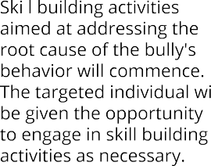
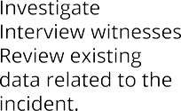
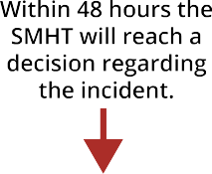
InterventIon | IDentIfy How to rePort Bully Ing
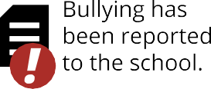
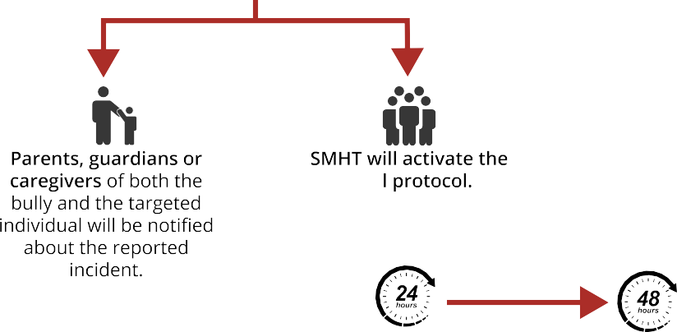
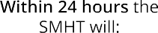
What can be expected after bullying is reported?

Parent, guardian or caregiver engagement at each level of the process is critical. The moment an incident is reported, the lead of the building’s school mental health team should notify both the parent of the alleged bully as well as the parent of the alleged target. This notification should activate the team to start the investigation, interviews, and collection and review of existing data for each student.

The findings of this process should be reported to each parent within 24 hours of the incident being reported. The SMHT should report their decision and their recommended course of action to the parent, guardian or caregiver so skill-building activities may begin.

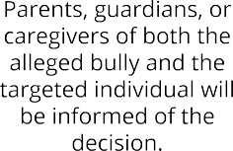

School Mental Health team Investigation

IntervIewS
Once a report is made, the SMHT will review it and interview both the alleged bully and the alleged target. The interview should include the teacher(s), bystander(s), upstander(s), administrator(s), and nurse(s) involved. The SMHT can refer to the 2-02 Bullying Interview form (to be completed with potential bully and potential target) and the 2-03 Teacher Interview of Bullying Incident Template.

teaM revIew
All data gathered should be reviewed by the SMHT in order to view each incident collectively and with multiple viewpoints present. KSDE recognizes not all districts have robust school mental health staff teams. Smaller districts should still review the information with multiple viewpoints. Best practice in determining the root cause of behavior is to attempt to see a whole child perspective of the behaviors. It is also important to consider all possible information in order to get an appropriate determination of a specific skill that needs remediation to decrease and potentially eliminate bullying.

evaluatIon of eXIStIng Data
The SMHT should gather information related to both the potential bully and the potential target. These documents should include, but may not be limited to any formal and informal teacher reports that are documents, nurse visits, academic records, office discipline referrals, attendance, standardized test scores, date of enrollment, 504/IEP/General Education Intervention plans, and any other functional behavioral assessment information. The SMHT can refer to the 2-04 Evaluating Existing Records Template.

DECISION
The SMHT must come to a conclusion if the behaviors reported and investigated qualify as bullying. The SMHT should refer to the 2-05 SMHT Investigation Template. If the SMHT determines the incident was not bullying, they should then determine what qualifies as a conflict, possible rude behavior, or meanness. Restorative practices are an evidence-based practice that may be implemented to help students involved in acts that are considered conflict, rudeness, or meanness in an effort to teach skills that could repair harm. Recreate the chart below without the bullying column. If the incident is a conflict, rude or mean behavior, restorative practices may be used to work with the students involved to attempt to repair any harm that was caused. This process would look different than if a student was given specific skill building instruction based on the need to build connection with the students, adult, or family member potentially involved in the reported incident.

Conflict | rude | Mean
Occasional | Occasional | Once or twice
Not planned; in the heat of the  moment | Spontaneous; unintentional | Intentional
All parties are upset | Can cause hurt feelings; upset | Can hurt others deeply
All parties want to work things out | Based in thoughtlessness, poor manners or narcissism | Based in anger; impulsive cruelty
All parties will accept responsibility | Rude person accepts responsibility | Behavior often regretted
An effort is made by all parties to
solve the problem
Can be resolved through mediation | Social skill building could be of  benefit | Needs to be addressed/should NOT be ignored

If the incident qualifies as bullying, the SMHT should develop an action plan for implementing skill-building training. This training should be for the bully. Skill-building may also be offered to the target of bullying. Skill building may also be given to bystanders if the team determines this is appropriate. Teaching replacement skills has been shown as an evidence-based practice to decrease bullying incidents from occurring again.

If any behaviors demonstrated were referred to the school resource officer or local law enforcement and the student was not taken into custody, more intense behavior supports may be appropriate. The team should also consider the outcomes of bullying on the person who was targeted. These outcomes should be supported through skills training as well for the person who was targeted. Outcomes may be any of the following:
- Psychosomatic outcomes can include physical illness and symptoms, sleep disturbances.
- Psychosocial outcomes can include depression, anxiety, low self-esteem, stress, suicidal attempts and ideation.
- Behavioral outcomes can include internalizing and externalizing behavioral problems and patterns.
- Social outcomes can include peer rejection, trouble resolving peer conflict, social and communication skill deficits, and increased levels of delinquent behaviors.
- educational outcomes can include academic deficits, poor academic outcomes, low levels of school
engagement, and increased absenteeism.

what if the behaviors investigated are suspected to be a crime?
If at any time the family or the SMHT reviewing the facts of a bullying incident believes a behavior reaches the threshold of being defined as a crime (see definitions below), local law enforcement should be contacted. The SMHT should stop their review and turn their information over to law enforcement. The school resource officer (SRO) can guide the SMHT in making a report of the incident to law enforcement. Each SMHT will have varying levels of licensure from district to district. KSDE reminds each professional to only practice procedures that are within the scope of their professional ethics and level of licensure.

Families may also report suspected criminal behavior to local law enforcement for investigation. This may result in a police report, charges potentially being filed, and/or arrests or other consequences enforced in compliance with local laws. Behaviors that rise to the level of a suspected crime are defined in the Kansas Bureau of Investigations Handbook and can be found at https://www.kansas.gov/kbi/info/docs/pdf/KIBRS%20Handbook%202019.pdf
Potential behaviors that are defined as a crime:
Intimidation
Intimidation involves an offender making some type of threat to the victim without actually using or displaying a weapon. Such threats can be made in person, over the phone, online, or in writing. (This is found on page 25 of the Kansas Bureau of Investigations (KBI) Handbook.)
threatening
To unlawfully place another person in reasonable fear of bodily harm through the use of threatening words and/or other conduct but without displaying a weapon or subjecting the victim to actual physical attack. This offense includes stalking. Can include phone call, message, and/or a note. (This is found on page 25 of the KBI Handbook.)
Harassment
A knowing and intentional course of conduct directed at a specific person that seriously alarms, annoys, torments, or terrorizes them, and serves no legitimate purpose. (K.S.A. 60-31a02).
assault
An unlawful physical attack by one person upon another where either the offender displays a weapon, or the victim suffers obvious severe or aggravated bodily injury involving apparent broken bones, loss of
teeth, possible internal injury, severe laceration, or loss of consciousness. (This is found on page 22 of the
KBI Handbook.)
Battery
A physical threat of attack by one person to another (assault) or an unlawful physical attack by one person upon another (found on page 21 of the KBI Handbook).
Disorderly Conduct
Acts that the person knows or should know will alarm, anger, or disturb others, or provoke an assault or
breach of the peace, including brawling, disturbing assemblies, or using “fighting words.” (K.S.A. 21-6203.)

Some Destruction of Property
Criminal damage to property means intentionally damaging, defacing, destroying, or substantially impairing the use of another person’s property, without their consent. (K.S.A. 21-5813.)

notify family
Families should expect a decision from the school within 24 hours of reporting bullying. Timely responses are important to both the person who is potentially being targeted and the potential bully. The school should contact the family with one of three findings:
- The incident was unfounded.
- The incident will be followed and monitored.
- Bullying was found.

With each finding, the school should explain any next steps recommended to the family. Any time a parent notifies the school of a potential incident, the SMHT can offer skill-building opportunities to the family and/or the student. The school may also contact the caregiver of the student identified as the bully and explain their student has demonstrated behaviors that are concerning or a violation of the school code of conduct and the SMHT would like to offer skill training to your child. The skills training offered should be shared with the
parent for clarity. If you refuse the option for skill training, administration may choose to implement disciplinary procedures according to district policies. It’s important to remind family members that SMHT members can only talk about their student’s findings with them.

SMHt Decision

Incident unfounded | Incident will Be followed | Bullying was found
The SMHT does not find evidence that meets the definition of bullying. | The SMHT does not find  evidence of bullying but there are behaviors that will have ongoing  monitoring and reviews. | The SMHT determined the evidence met the definition of bullying.  Skill building interventions will begin.
SMHT members should craft a district letter for each incident described above (see 2-06 Sample letter to Caregiver Outcome of Bullying Investigation). All formal letters should be reviewed and approved by district administrators prior to sending to the family.

BULLYING PREVENTION TOOLKIT
Postvention

Bullying Prevention 12 Step Plan

INTERVENTION
PREVENTION
Deﬁne Behaviors
Establish
SMHT
Train
Notify
Parent
Local Formal Appeal Process
POSTVENTION

Monitor Progress

Identify
Skill Deﬁcit

Interview

Team Review

Decision

Investigate

Reporting
Process

This page blank for printing purposes.

Skill training
Kansas school districts have access to free resources through the TASN Kansans Can Competencies project. The
26 “Skills That Matter” from the Kansans Can Competencies are applicable at all grade levels and for students at all ability levels. The School Mental Health Advisory Committee recommends the Kansans Can Competency Framework be used to identify possible areas for growth through skill-building where an area is identified as missing or weak. Skill-building should be required for the bully as well as offered to the person being targeted.
Evidence is being collected on offering skill building for bystanders and upstanders. The ultimate goal of working
on skill building is to increase social and communication skills while decreasing bullying.





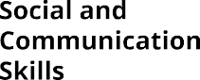
KSDE recommends focusing on the skills identified in the Kansans Can Competencies. These 26 skills help students at any age level build skills that provide foundations for development that will lead to outcomes for future success. The resources to work on these competencies are at no cost to Kansas schools: https://www.cccframework.org/KScan/

PoStventIon | SKIll BuIlDIng | ProgreSS MonItorIng

FOCUS ON THE SKILLS THAT MATTER
The College & Career Competency Framework1 supports educators and families in developing resilient learners who collaborate to expand skills, express their wants and needs respectfully, and apply strategies to self-regulate and persevere.
Educators can provide Tier 1 instruction and then identify areas where students need additional supports in self-regulation, self-efficacy, assertiveness, or conflict management. A Tier 3 intervention cycle2 is focused on competency-specific strategies to improve in-school and post-school outcomes.

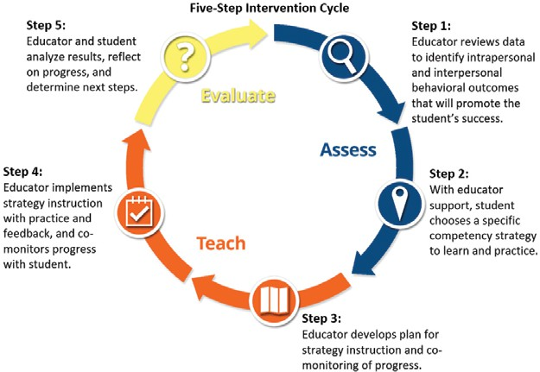
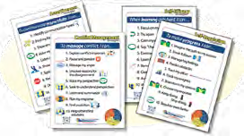
Free K–12 curricula, including student workbooks, assessments, and student videos, are available now to Kansas educators. Kansans Can Competency Framework. https://www.cccframework.org/KScan/
Once the SMHT determines the skill deficit based on the information from the review of records and interviews, an action plan for intervention should be put into place and progress monitoring should be scheduled. For documenting skill-building efforts, the SMHT can use the 3-01 Student Skill Building Report. For tracking progress, the SMHT may refer to the relevant attachment as well.
Progress Monitoring
To determine the effectiveness of the skill-building implementation, goals should be set by the team prior to implementation. Progress monitoring on these goals should occur regularly and be continuous. The intervals for progress monitoring should be determined by the SMHT based on the strengths and abilities of each student involved. The SMHT should also determine if and when supports may be tapered. Progress monitoring as well as the plan for tapering the activities should be clearly communicated to the family. The SMHT may follow the 3-02 SMHT Progress Monitoring Template as they monitor student progress during postvention.

1 College & Career Competencies Framework. (n.d.). https://www.cccframework.org/
2 College & Career Competency Framework Guidance for individualized supports. (n.d.). https://www.cccframework.org/individualized-supports/

appealing a Decision
Each district should include within their policies, procedures, and practices a process for parent(s)/guardian/ caretakers to follow if they disagree with the findings of the SMHT. In 2025, the Kansas State Board of Education voted unanimously that clear messaging on how to report bullying, trainings offered, the process that will be followed once bullying is reported, and the process to appeal a decision should be posted on each school district’s website. This should also be posted in student handbooks for students to reference. School personnel and parents are encouraged to seek resolution of any disagreement through mutual collaboration and communication. The Kansas Association of School Boards (KASB) may provide guidance for skill building with school administration as well as their local board of education members for mediation of disagreements. Families Together may also be a resource to help families navigate this process.

Following the local chain of command for any disagreement in the district is standard operating procedure. Creating a flow of how this should look and clearly communicating this with all parent(s)/guardians/caretakers should be a priority. Here is an example of information that should be shared with parents related to bullying findings from the SMHT:

School Mental Health Team (SMHT) determination.

- If you disagree with the SMHT decision.
Appeal the determination to the SMHT.

3. If you disagree with the principal’s decision.
Contact the building principal.
- If you still disagree with the SMHT decision.

Contact the superintendent.

4. If you disagree with the supintendent’s decision.
Contact the local board of education.

POST VENTION

If a parent/guardian does not agree with the SMHT’s conclusion after they have reviewed the information available to them, they should schedule time to discuss this with the team. At any time, a parent may also reach out to the Office for Civil Rights. The Office for Civil Rights can be reached here: https://www.ed.gov/laws-and-policy/civil-rights-laws/file-complaint
The OCR office for Kansas is located at: Kansas City Office
Office for Civil Rights
U.S. Department of Education One Petticoat Lane
1010 Walnut Street, 3rd floor, Suite 320
Kansas City, MO 64106
Telephone: 816-268-0550
FAX: 816-268-0599
TDD: 800-877-8339
Email: OCR.KansasCity@ed.gov

The National Office of Civil Rights is located at:
U.S. Department of Education
Office for Civil Rights
Lyndon Baines Johnson Department of Education Bldg.
400 Maryland Avenue, SW Washington, DC 20202-1100
Telephone: 800-421-3481
FAX: 202-453-6012
TDD: 800-877-8339
Email: OCR@ed.gov

PoStventIon | aPPealIng a DeCISIon
RACE, COLOR,
NATIONALITY
DISABILITY
GENDER

The Office for Civil Rights traditionally will get involved with any incidents that are related to the following
circumstances:

FEDERAL CIVIL RIGHTS LEGISLATION

TITLE VI

TITLE IX
BULLYING AND HARASSMENT
REHAB ACT
ADA

This page blank for printing purposes.

BULLYING PREVENTION TOOLKIT
resources

This page blank for printing purposes.

Special attention note: the Intersection of Bullying and Suicide
There is a strong link between bullying and suicide, as suggested by recent bullying-related suicides in the U.S. and other countries. Caregivers, teachers, and students should learn the dangers of bullying to help proactively support students who may be at risk of dying by suicide.

In recent years, a series of bullying-related suicides in the U.S. and across the globe have drawn attention to the connection between bullying and suicide. Though too many adults still see bullying as “just part of being a kid,” it is a serious problem that leads to many negative effects for the students being targeted, including suicide.
Many people may not realize there is also a link between being a bully and committing suicide. the statistics on
bullying and suicide are alarming:
- Suicide is the third leading cause of death among young people, resulting in about 4,400 deaths per year, according to the CDC. For every suicide among young people, there are at least 100 suicide attempts. More than 14 percent of high school students have considered suicide, and almost 7 percent have attempted it.
- The students being targeted are between two to nine times more likely to consider suicide than those who are not bullied, according to studies by Yale University.
- A study in Britain found at least half of suicides among young people are related to bullying.
- Ten- to 14-year-old girls may be at even higher risk for suicide, according to the study above.
- According to statistics reported by ABC News, nearly 30 percent of students are either bullies or the students being targeted, and 160,000 kids stay home from school every day because of fear of bullying.
Bullying-related suicide can be connected to any type of bullying, including physical bullying, emotional bullying, cyberbullying, and sexting, or circulating suggestive or nude photos or messages about a person.

Some schools or regions have more serious problems with bullying and suicide related to bullying. This may be due to an excessive problem with bullying at the school. It could also be related to the tendency of students who are exposed to suicide to consider suicide themselves.

Some of the warning signs of suicide can include the following:
- Showing signs of depression, like ongoing sadness, withdrawal from others, losing interest in favorite activities, or trouble sleeping or eating.
- Talking about or showing an interest in death or dying.
- Engaging in dangerous or harmful activities, including reckless behavior, substance abuse, or self injury.
- Giving away favorite possessions and saying goodbye to people.
- Saying or expressing they can’t handle things anymore.
- Making comments that things would be better without them.
If a person is displaying these symptoms, talk to them about your concerns and get them help right away, such as from a counselor, doctor, or at the emergency room.

SPeCIal attentIon note: tHe Inter SeCtIon of Bully Ing anD SuICIDe
In some cases, it may not be obvious a teen is thinking about suicide, such as when the suicide seems to be triggered by a particularly bad episode of bullying. In several cases where the students being targeted killed themselves, bullies had told the teen that he or she should kill him or herself or that the world would be better without them. Others who hear these types of statements should be quick to stop them and explain to the victim the bully is wrong.
other ways to help people who may be considering suicide include:
- Call, text, or chat online with 988. A mobile crisis and stabilization support person can be requested to
come to the person and help work through the crisis.
- listen and stay with the person. If you are not comfortable or trained to assist in supporting a person in
crisis, stay with them until you can facilitate a warm handoff to someone who can support them.
  - Listen to them and show empathy for how they feel.
  - Read through https://ksafriendasks.ag.ks.gov/
- take all talk or threats of suicide seriously. Don’t tell the person they are wrong or that they have a lot to live for. Instead, get them immediate medical help.
- Decrease access to lethal means. Keep weapons, sharp items, ligatures, and medications away from anyone who is at risk for suicide. Getting the person to identify if they have considered a method is the most effective way to support them by taking these items out of the house or at least keeping items securely locked up.
- Parents should encourage their teens to talk about the bullying that is happening. It may be embarrassing for kids to admit they are the the students being targeted, and most kids don’t want to admit they have been involved in bullying. Tell the students being targeted it’s not their fault they are being bullied and show them love and support. Get them professional help if the bullying is serious.
- It is a good idea for parents to be included in their children’s friends on social networking sites so they can see if someone has posted mean messages about them online. Text messages may be more difficult to know about, so parents should try to keep open communication with their children.
- Parents who see a serious bullying problem should talk to school authorities about it, and perhaps arrange a meeting with the bully’s parents. More states are implementing laws against bullying, and recent lawsuits against schools and criminal charges against bullies show there are legal avenues to take to deal with bullies. If school authorities don’t help with an ongoing bullying problem, local police or attorneys may be able to.
People who are thinking about suicide should talk to someone right away or go to an emergency room. They can also call a free suicide hotline, 1-800-273-TALK (8255).

Friends and relatives of suicide also need to find someone to talk to as they grieve, especially if they are suffering
from depression or suicidal thoughts.

CONCLUSION
SPeCIal attentIon note: tHe InterSeCtIon of BullyIng anD SuICIDe

Bullying is not a “right of passage” or an experience any child should have to experience during their school years. Bullying is a sign of a skill deficit that requires intentional instruction, support, and progress monitoring. Schools that work to develop strong skills in students, staff, and parents are more likely to develop a culture of caring and support. The evidence-based practices in this toolkit have been recommended for implementation to facilitate a supportive culture of learning and growth. District-wide implementation of culture building programs serve to assist schools in proactive identification of harm and postvention repair of harm through skill-building
if and when harm occurs. Developing a schoolwide culture that is positive and supportive allows an upstander culture of support, caring, and growth. KSDE and the SMHAC believe districts that implement bullying prevention in accordance to the recommendations within this toolkit have the potential to show measures of success and a Kansas culture that can thrive.
resource:
Bullying and Suicide - Bullying statistics. Bullying Statistics.
http://www.bullyingstatistics.org/content/bullying-and-suicide.html

School Mental Health Bullying Prevention workgroup Members
Co-Chairs
Betty Arnold, District 8, Kansas State Board of Education
Dr. Jane Groff, Executive Director, Kansas Parent Information Resource Center (KPIRC)

Members
Samantha Brown, Manhattan-Ogden USD 383
Tracie Chauvin, Kansas City USD 500; Kansas School Social Workers Association
Zenah Chepkwony, Haysville USD 261
Kelsee Fout, Kansas Department of Health and Environment Kiley Luckett, Lawrence USD 497
Judi Rodman, President and CEO, Sunflower House
Marcia Weseman, Kansas Association of School Boards
Holly Yager, Wabaunsee USD 329; Kansas Association of School Psychologist

BULLYING PREVENTION TOOLKIT
appendix

This page blank for printing purposes.

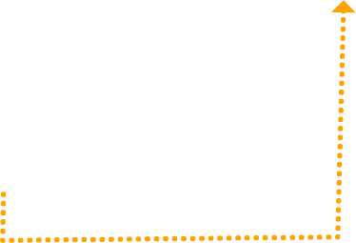
Bullying Deﬁnition
NO
YES
NO
YES
BULLYING
NO
YES
NOT
B G
ULLYIN
Results in reasonable fear of damage to property
YES NO
YES NO
YES NO
YES NO

Results in actual damage to property
Results in reasonable fear of physical or mental harm

Results in actual physical or mental harm
Creates an intimidating, threatening or
abusive educational environment
Severe, persistent or pervasive
Intentional Act
(gesture; written, verbal or electronic communication; physical act; or threat)

  - SMHT Identification Tool

The following table serves as a tool to help districts identify who their SMHT will consist of and to clarify the roles of certain members.
this team must be posted to your local website and communicated with parents and/or caregivers.

ROLE | RESPONSIBILITIES | PERSONNEL | CONTACT INFORMATION (PHONE & EMAIL) | TRAINED TO SCREEN FOR SUICIDE RISK?
SMHT  Coordinator | D Coordinates annual training for the SMHT, school faculty, and staff members.  D Mobilizes team members as  needed.  D Coordinates team member assignments.  D Coordinates prevention education and resources for school staff members, students, and families.  D Acts as the liaison between the school, family members, and community members. |  |  | D
SMHT  Assistant Coordinator | D Fulfills duties above when SMHT  Coordinator is unavailable.  D Coordinates communication among staff members, students, families, and community members.  D Shares updates with SMHT.  D Facilitates communication with caregivers/guardians when concerns arise. |  |  | D
School Mental Health Professionals | D Conducts student interviews to identify potential suicide risk using a suicide screening tool.  D Provides a safe and comfortable environment for students and families.  D Connects students and families to community resources when appropriate.  D Documents actions. |  |  | D

  - Bullying Involvement Investigation Process Checklist

The purpose of this checklist is to guide the bullying prevention task force in conducting a thorough investigation. Please ensure that all four steps are completed when conducting a bullying incident investigation. Any related items used/steps taken that are not listed should be placed in the “additional items” section within the respective step.
- Throughout the process, student information must be kept confidential.
- Ensure that reports and other documentation are stored securely.
- Conduct interviews in a setting where others will not overhear.
- Do not discuss the details of the incident with anyone who does not have a legitimate educational interest in the information.
- Follow state and federal pupil records statutes in conjunction with district confidentiality policies.
- Ensure all steps in the recommended 12-step plan are implemented:

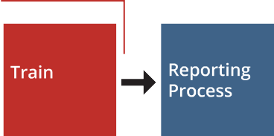

Bullying Prevention 12 Step Plan

  - Bully Ing InvolveMent InveStIgatIon ProCeSS CHeCKlISt

STEP ONE: RECEIVE REPORT
tools:
- Bullying Report Form: General
- Bullying Report Form: Anonymous
- Bullying Report Form: Verbal
- Elementary Bullying Report Form
- Secondary Bullying Report Form

PROCEDURE | SIGNATURE | DATE
Review all bullying reports related to the incident within two days.
Analyze all information in the bullying report (e.g., date, age/grade
level, nature of the incident, individuals involved).
Additional items:

STEP TWO: revIew eXIStIng Data
tool:
- Evaluating Existing Records

PROCEDURE | SIGNATURE | DATE
Complete review of existing data sources.
Additional items:

  - BullyIng InvolveMent InveStIgatIon ProCeSS CHeCKlISt

STEP THREE: ConDuCt IntervIewS
tools:
  - Student Interview Form
  - Brief Teacher Interview Form

PROCEDURE | SIGNATURE | DATE
Conduct interviews with students involved in the bullying incident.
Conduct teacher interviews.

STEP FOUR: DeCISIon MaKIng anD follow-uP
tools:
  - Investigation Decision Making Form
  - Consequences and Supports Form
  - Follow-Up Form

PROCEDURE | SIGNATURE | DATE
Determine if the incident is considered bullying using the investigation decision making worksheet.
If the incident is bullying and meets the threshold of a suspected crime, please contact your school resource officer or local police to consult with them.
Establish an action plan using the skill building support plan document.
After two weeks, hold a follow-up meeting to discuss the case using the follow-up worksheet.
Additional items:

  - Bullying Report Template
BullyIng InCIDent rePort
To be completed by a witness, person who was bullied, or person with information regarding a bullying incident.
Name of individual filling out form I am a (choose one option):

D Student
D Staff

Would you prefer to remain anonymous? | D Yes | D No

Are the target of the bullying that you are reporting? | D Yes | D No
InCIDent InforMatIon
Date of incident Time of incident

Person(s) being reported as tHe StuDent(S) BeIng targeteD:
D Parent
D Other

D Student D Staff

D Student D Staff

D Student D Staff

D Student D Staff Person(s) being reported as engagIng In BullyIng BeHavIorS:
D Student D Staff D Other

D Student D Staff D Other

D Student D Staff D Other

D Student D Staff D Other Person(s) wItneSSeD BullyIng BeHavIorS:
D Student D Staff D Other

D Student D Staff D Other

D Student D Staff D Other

D Student D Staff D Other

loCatIon(S)
Student(s) experienced bullying in the following place(s):
  - BullyIng rePort teMPlate

D Classroom D Cafeteria D Bathroom
D Hallway
D Locker room
D Bus
D Bus Stop
D Gym
D Online
D School or related activity or event
D Extracurricular activity

D Other:

tyPeS of BullyIng BeHavIor
Student(s) were targeted for bullying in the following way(s). Check all that apply.

D Electronic devices (e.g., internet, social media platforms, text, email, cyberbullying, etc.)
D Written communication (e.g., handwritten notes, other written documents, email, etc.)
D Physical act or conduct (e.g., pushing, hitting, destruction of property, stalking, etc.)
D Verbal act or conduct (e.g., rumors, lies, name-calling, using derogatory slurs, etc.)
D Social (e.g., purposeful exclusion, causing psychological harm, etc.)
D Items depicting implied hatred or prejudice were worn, possessed, or displayed

D Other:

Please tell us about the incident in your own words. Use as much detail as possible. Attach a written statement if more space is required.

D The above information is true and accurate to the best of my knowledge.

Signature Signed date

  - Bully Ing rePort teMPlate

BullyIng rePort follow uP

Report received (date): Received by: Investigation begins (date):

BullyIng PreventIon taSK forCe MeMBerS
Names of investigators:

fInDIngS froM InveStIgatIon

ACTIONS TAKEN

Administration reviewer Date reviewed by administration

  - Bullying Interview

SCHool Mental HealtH teaM PotentIal BullyIng IntervIew

Name |  |  | Today's date
Interviewer name
InCIDent InforMatIon  Location | Date of incident |  | Time of incident

otHerS InvolveD
D Student D Staff D Other
D Bystander D Witness D Upstander

D Student D Staff D Other
D Bystander D Witness D Upstander

D Student D Staff D Other
D Bystander D Witness D Upstander

D Student D Staff D Other
D Bystander D Witness D Upstander

anteCeDentS to tHe event (BaCKStory)

  - Bully Ing Interv Iew

Intent of BeHavIor

was behavior:
D Severe D Persistent D Pervasive D Or all of these
Harm caused to target:

Perception of the person involved:

Potential bully:

Potential target:

Was there intimidation perceived? D Yes D No

Did the target feel threatened? D Yes D No

Did the target feel the educational environment was abusive? D Yes D No

Did physical or mental harm occur? D Yes D No

Did the target experience reasonable fear of physical or mental harm? D Yes D No

Was there property damage? D Yes D No

Does the target fear damage to their property? D Yes D No

APPENDIX
  - Teacher Interview of Bullying Incident Template

teaCHer IntervIew of BullyIng InCIDent
Teacher name Today's date

relatIonSHIP to StuDent(S):
Bully:

Student being targeted:

How long Have tHey Known StuDent(S):
Bully:

Student being targeted:

StuDent StrengtHS:
Bully:

Student being targeted:

areaS to IMProve
Bully:

Student being targeted:

aCaDeMIC funCtIonIng
Bully:

Student being targeted:

  - teaCHer Interv Iew of Bully Ing InCIDent
SoCIal funCtIonIng/Peer InteraCtIonS
Bully:

Student being targeted:

CoMMunICatIon aBIlItIeS
Bully:

Student being targeted:

CHangeS In BeHavIor
Bully:

Student being targeted:

AREAS OF CONCERN
Bully:

Student being targeted:

  - Evaluating Existing Records Template
Review existing data about students involved in the bullying report. Examples of data to consider reviewing include formal and informal teacher reports, nurse visits, academic records, office discipline referrals (ODRs), attendance, standardized test scores, date of enrollment, 504/IEP records, and assessment data. Note anything that appears related to this student's functioning or development, prior incidents, or similar behaviors. The task of evaluating existing records should be completed by an administrator, pupil services professional, or other staff member who has easy access to
the relevant pupil records. Throughout the process of investigating bullying concerns, the confidentiality of student information should be maintained in accordance with local, state, and federal policies.

Your name Student's name Date of review

Formal and information teacher reports

Nurse visits

Academic records

Office discipline referrals (ODRs)

  - SMHt evaluatIng e XIStIng reCorDS teMPlate
Attendance records

Standardized test scores

Date of enrollment

504 plan or IEP

Assessment data

2- 04 SMHt evaluatIng e XIStIng reCorDS teMPlate
Other (specify):

Other (specify):

Other (specify):

What evidence did you find from the existing data? (Summary)

What conclusions did you draw?

  - SMHT Investigation Template

Name(s) of bullying prevention task force member(s): | Date

Name of individual who was targeted:

Name of individual who engaged in bullying behavior:

Was there an imbalance of power between the individuals involved? D Yes D No Describe:

Did the individual who engaged in bullying behavior have intent to cause physical, emotional, or social harm?
D Yes D No Describe:

Is this a repeated pattern, or without intervention likely to be repeated for the individual who engaged in bullying behavior? D Yes D No
Describe:

Is this a repeated pattern, or without intervention likely to be repeated for the individual who was targeted?
D Yes D No Describe

Based on information, did the bullying prevention task force determine this incident was considered bullying?
D Yes D No Describe:

2- 05 SMHt InveStIgatIon teMPlate
Supportive Measures for individual who was targeted:

D Communication and collaboration with parents
D Social skills instruction
D Functional Behavior Assessment
D Communication skills instruction (e.g. advocacy skills)
D Meet with school counselor, social worker, psychologist, etc.
D Increased support by school staff
D Environmental accommodations (e.g. alternate passing)
D Other:

Next Steps for individual who engaged in bullying behaviors:
D Communication and collaboration with parents
D Social skills instruction
D Functional Behavior Assessment
D Communication skills instruction
D Meet with school counselor, social worker, psychologist, etc.
D Increased support by school staff
D Other:

Sample letter to Caregiver Outcome of Bullying Investigation
2-06

(INSERT SCHOOL LETTERHEAD)

Letter to Caregiver

Outcome of Reported Potential Bullying Investigation - Confirmed

Date
Name of Caregiver Address
City, State Zip

RE: Student Name

Dear (INSERT CAREGIVER NAME) ,

This letter is to notify you that your child's School Mental Health Team (SMHT)) has reviewed the incident reported as potential bullying. We have options available to support your student through skill building lessons that have shown to decrease bullying behaviors and increase social skills that we believe will support your child. What has been shared with USD XXX has demonstrated that bullying was identified. Please work with
your school team to discuss the plan they have identified. If you refuse the options your school is offering, your
building administrator may choose to implement other consequences as outlined by school policy."

Please reply as soon as possible so we can move forward with your child. We look forward to supporting their education.

Respectfully,

Team Lead's Name

  - Student Skill Building Report

SMHt StuDent SKIll-BuIlDIng DoCuMentatIon
next steps for individual who was targeted:
D Communication and collaboration with parents.
D Social skills instruction.
D Functional Behavior Assessment
D Communication skills instruction.
D Meet with school counselor, social worker, psychologist, etc.
D Increased support by school staff.
D Other:

Note when the support occurred, with whom and the result:

If the behavior was not rectified, which different support was utilized?

Note when the support occurred, with whom and the result:

  - StuDent SKIll BuIlDIng rePort

next steps for individual who engaged in bullying behaviors:
D Communication and collaboration with parents.
D Social skills instruction.
D Functional Behavior Assessment
D Communication skills instruction.
D Meet with school counselor, social worker, psychologist, etc.
D Increased support by school staff.
D Other:

Note when the support occurred, with whom and the result:

If the behavior was not rectified, which different support was utilized?

Note when the support occurred, with whom and the result:

  - StuDent SKIll BuIlDIng rePort

Identified skills to strengthen:
D Cognitive skills D Creative thinking D Organization
D Time management D Problem-solving D Learning schema D Content/technical D Critical thinking
Interpersonal Skills
D Adaptability D Assertiveness D Teamwork
D Empathy
D Networking
D Social awareness
D Conflict management
D Communication

Intrapersonal Skills
D Initiative
D Perseverance D Self-regulation D Self-awareness D Self-efficacy
D Self-care D Curiosity D Ethics

This form adapted In collaboration with University of Missouri.

  - SMHT Progress Monitoring Template

SMHt ProgreSS MonItorIng
To be completed at least two weeks following the implementation of next steps outlined on the Investigation Decision Making Sheet and the Consequences and Supports Documentation.

Are the students still involved in bullying? D Yes D No Describe:

Do the next steps for the person who engaged in bullying behavior appear to be effective?
D Yes D No

Describe:

Do the next steps for the person who was victimized appear to be effective?
D Yes D No

Describe:

Are there any additional supports or changes that should be made for these individuals?
D Yes D No

Describe:


Kansas State Board of Education
BOARD MEMBERS

900 SW Jackson Street, Suite 600
DISTRICT 1
D 2 DISTRICT 3

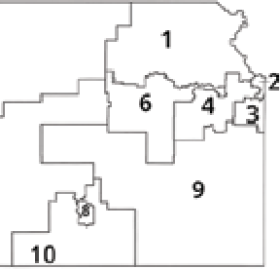




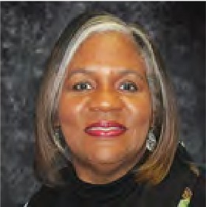





t
ISTRICT

elanie Ha nie.Haas@ gov
DISTRICT 4
DISTRICT 5

Topeka, Kansas66612-1212 Danny Zeck M as Michelle Dombrosky Connie O'Brien Cathy Hopkins
(785) 296-3203 Vice Chair Mefa ksde. Michelle.Dombrosky@ Connie.O'brien@ksde. Chair
Danny.Zeck@ksde.gov ksde.gov gov Cathy.Hopkins@ksde.
www.ksde.gov/board gov

DISTRICT 6 DISTRICT 7 DISTRICT 8 DISTRICT 9 DISTRICT 10

7

SUCCESS DEFINED
A successful Kansas high school graduate has the
- Academic preparation,
Dr. Beryl A. New
Beryl.New@ksde.gov

MISSION
Dennis Hershberger Dennis.Hershberger@ ksde.gov
Betty Arnold
Betty.Arnofd@ksde.gov
Jim Porter
Jim.Porter@ksde.gov
Debby Potter
Debby.Potter@ksde.gov

- Cognitive preparation,
- Technical skills,
- Employability skills and
- Civic engagement
to be successful in postsecondary education, in the attainment of an industry recognized certification or in the workforce, without the need for remediation.
OUTCOMES
- Social-emotional growth
- Kindergarten readiness
- Individual Plan of Study
- Civic engagement
- Academically prepared for postsecondary
- High school graduation
- Postsecondary success
*
To prepare Kansas students for lifelong success through rigorous, quality academic instruction, career training and character development according to each student's gifts and talents.

VISION
Kansas leads the world in the success of each student.

MOTTO
Kansans Can

�

�

Kansans

CAN

For more information, contact:
Trish Backman
School Mental Health Coordinator Special Education and Title Services
(785) 296-6937
trish.backman@ksde.gov

Kent Reed
Program Manager
Career, Standards and Assessment Services (785) 296-8109
kent.reed@ksde.gov

Kansas State Department of Education

900 S.W. Jackson Street, Suite 102
Topeka, Kansas 66612-1212

www.ksde.gov





@ksde.bsky.social kansasdoe @ksdehq

